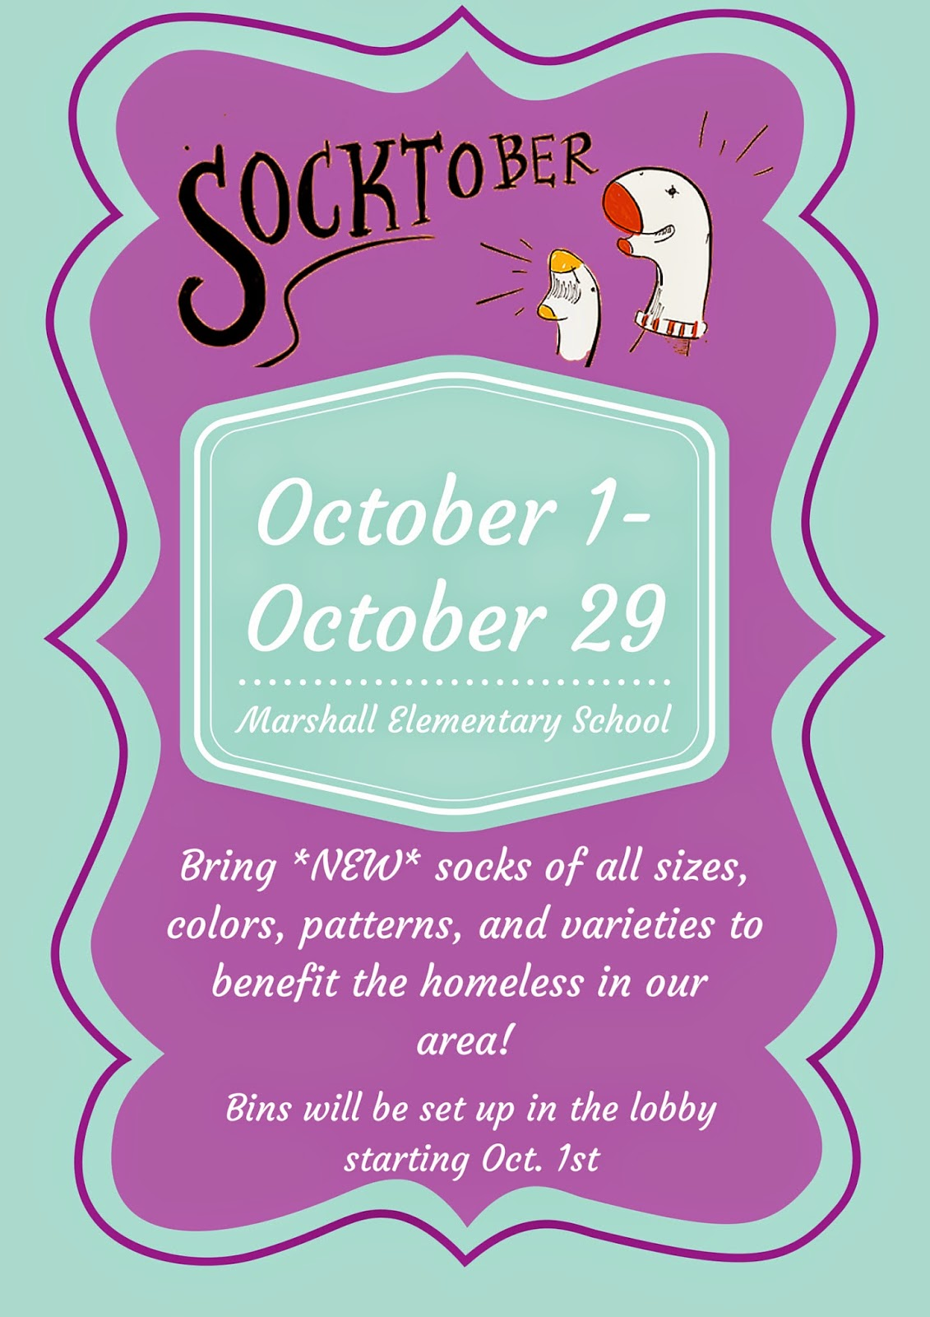

October 1st-31st

MedQuest College Sock Drive